Database scheme design:
- pageId (URL, PageId)
- wordId (Word, WordId)
These two are dictionaries for mapping URL and Word to PageId and WordId respectively. The id value can be computed by a hash function based on the ASCII code to an integer number.

- word (WordId, word)
This is for retrieve the original word from the WordId.

- PageInfo (PageId, title, LastModDate, size, url, HubWeight, AuthWeight)
This table is for the page basic information, such as tile, last modification date, size of page etc. URL is also included in case we need to retrieve the url from given pageID It could also include hub weight and authority weight, which are computed through the children and parent links respectively.

- WordTF ( WordId, (DocFreq, List<(PageId, tf)>) )
The value in the (key, value) pair is implemented as an object which contains the document frequency as well as the posting list of (PageId, TermFreq) pairs, as illustrated as below. This is for the fast comparison between the query and the documents containing the key words. If in later stage the positing list becomes the performance bottleneck as it is too long, we can further partition the posting lists to several tables, which have the same keys, to do parallel searching. In the same way, we can do horizontal partition separating key words in to different tables if the performance bottleneck is at finding the key words.

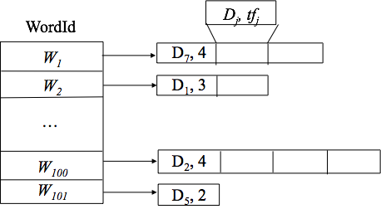

- InvertedWord ( PageId, List<WordId>)
The ForwardList table is introduced to support deletion of a webpage entry. The value for each PageId key is a list of keywords it contains, as shown below. Upon deletion, we will retrieve the forwarding list for this particular webpage and update the InvertedList accordingly.

- ParentLink (PageId, List<ParentId>);
- ChildLink (PageId, List<ChildId> )
These two tables are introduced in case we want to implement PageRank or so in later stage. The value in the (key, value) pair is implemented as a linked list. It stores the PageIds of those who have links towards this page for ParentLink table and the PageIds of those pointed by this page as ChildLink Table. It can be seen as a condensed version of the directed adjacency matrix, which removed all zero entries and recored in the form of linked list.
Comparing to the complete adjacency matrix, which is believed to be quite sparse, using the two linked list tables can save a lot of space. And if in later stage the number of pages is large, it is possible that the adjacency matrix cannot fit into one memory page. In this case the searching can result in multiple hard disk read, which would consume a considerable amount of time
When it is the time to compute the exact hub weight and authority weight, we can either reconstruct the adjacency matrix from the two tables and compute eigenvectors, or we can iteratively do the computation for reasonable times.

- hubWeight (PageId, weight)
- authWeight (PageId, weight )
These two tables stores the computed hub weights and authority weights for each page.

